AMDT Student Hub Website

**Wireframes**

Landing Page

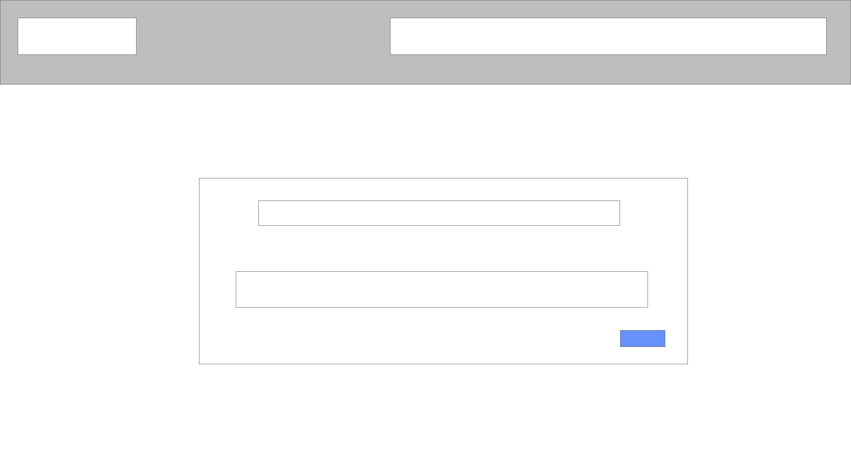Pop Up

Contact Us

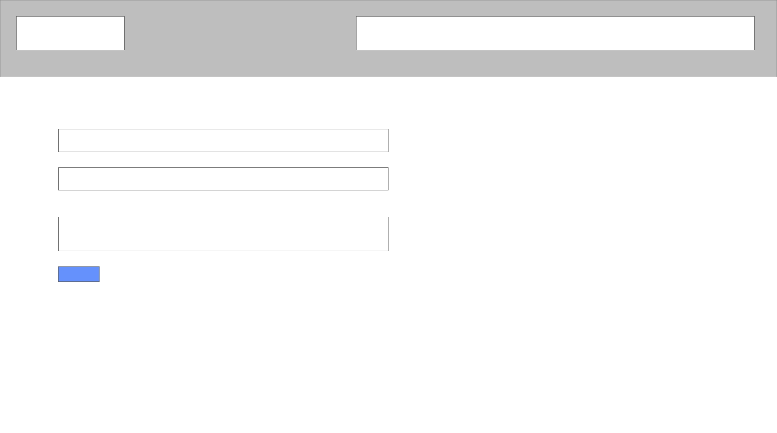

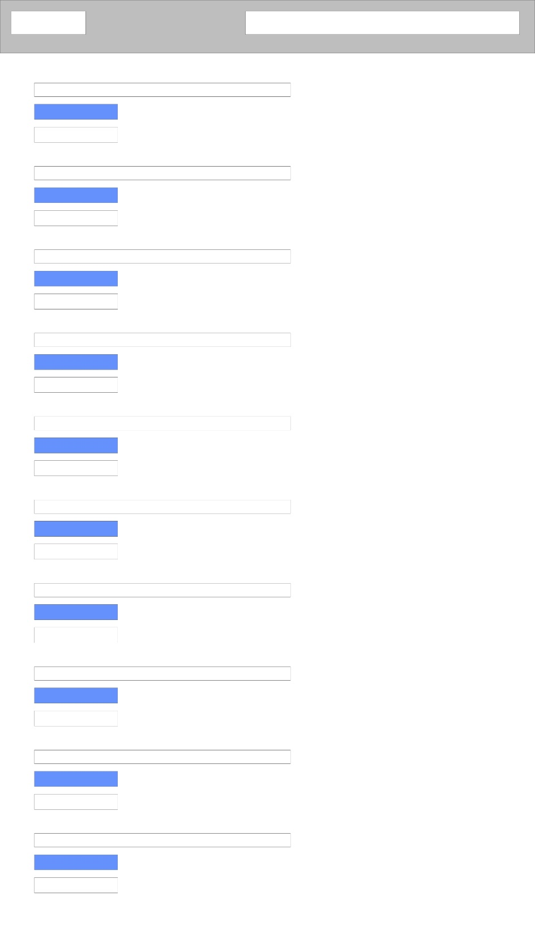AMDT Quiz

About the developer

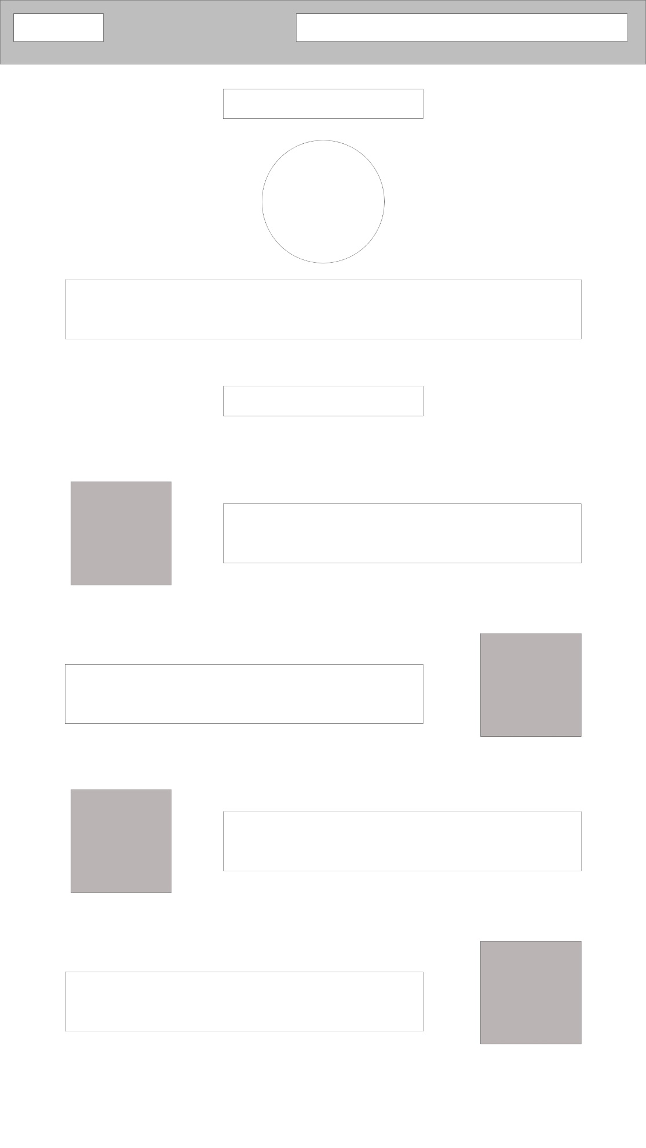

My Creative Page

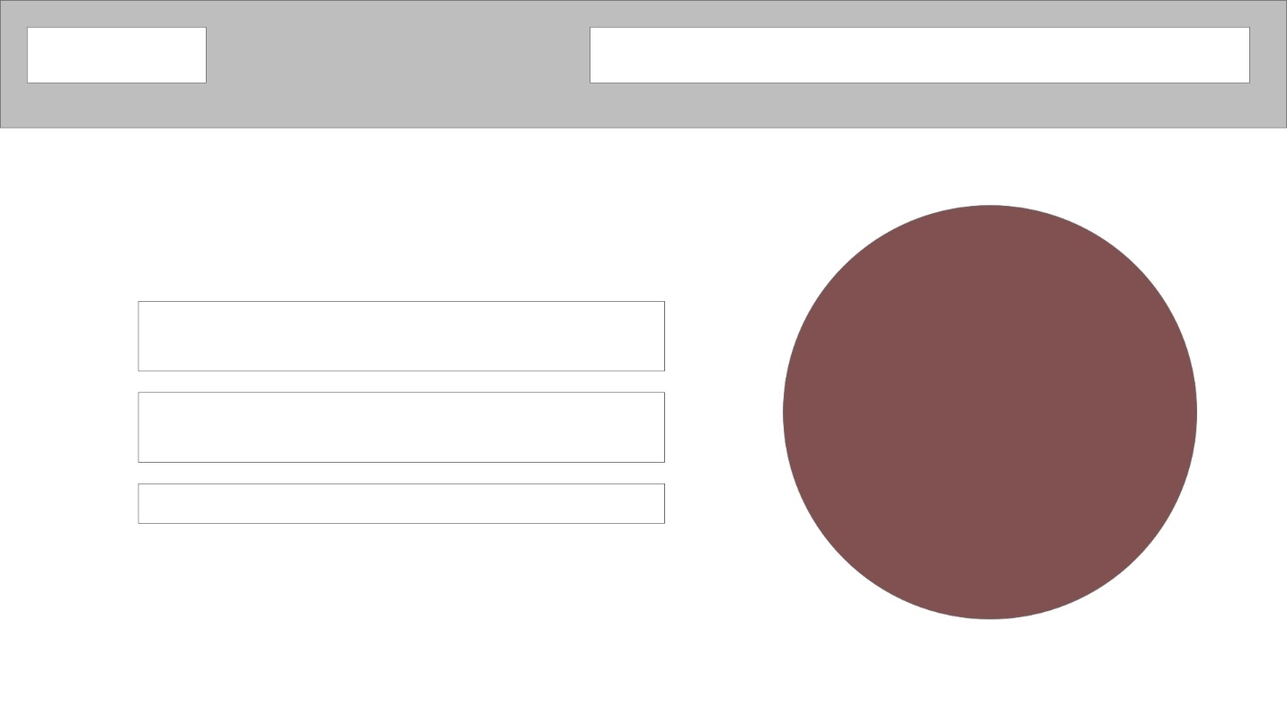

**Code snippets and screenshots of the website and technical justifications**

**Navigation Bar**

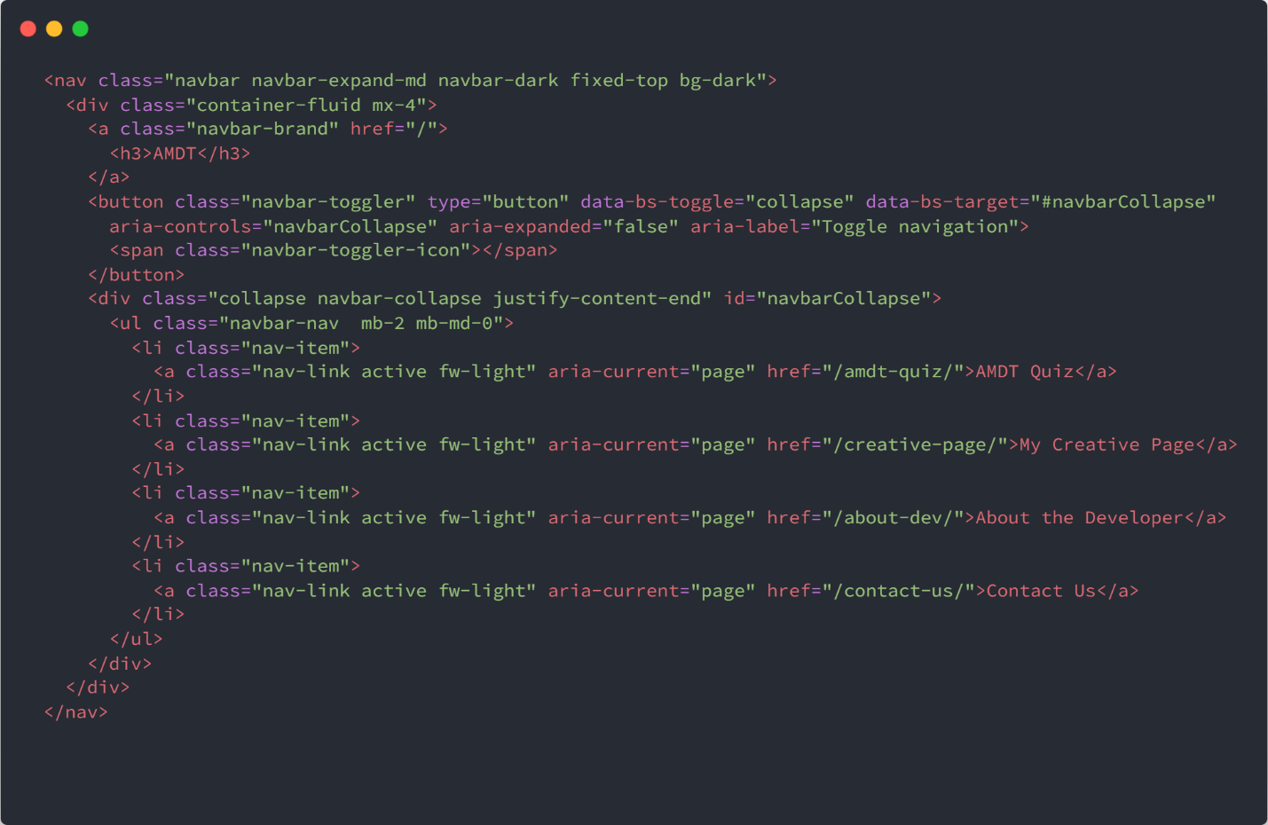

We have utilized bootstrap to create the navigation bar and have created it as a list. It’s a mobile optimized navigation bar, it comes with bootstrap.

Pop Up

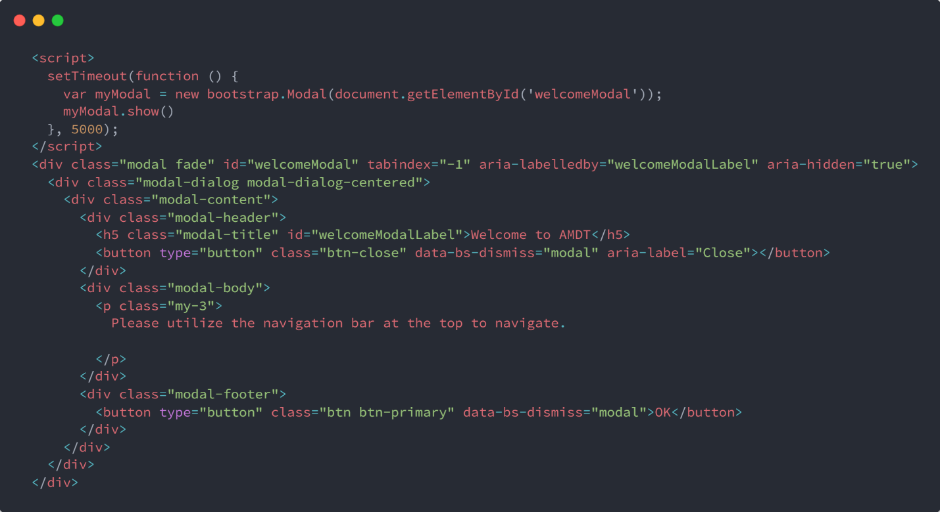

We have utilized bootstrap modals for this pop up. and we have set a time out using JavaScript for this pop up

Landing Page

* Video

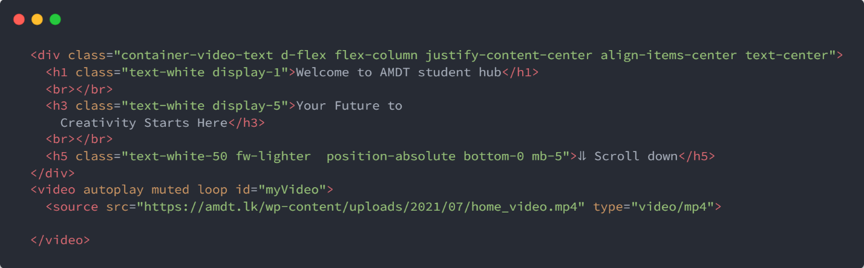

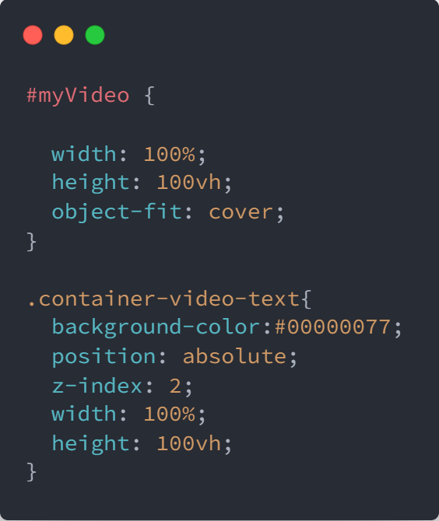CSS

We have added a text and we have put position-absolute, technically it detached from the website. For the background we have added a video.

Features / Qualification of Amdt

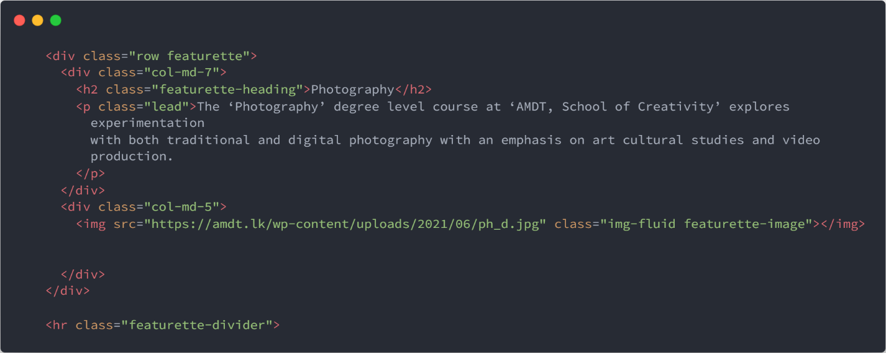

CSS

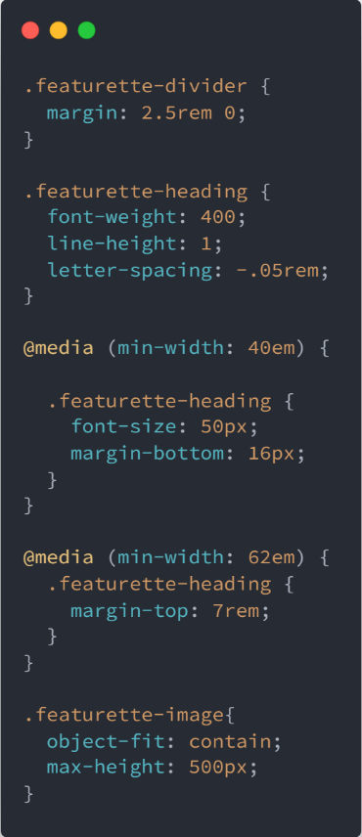

We have utilized bootstrap columns for these elements.

About the developer

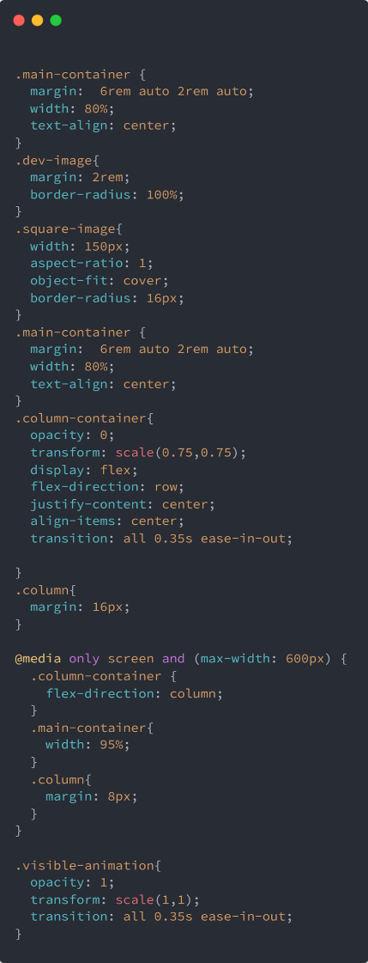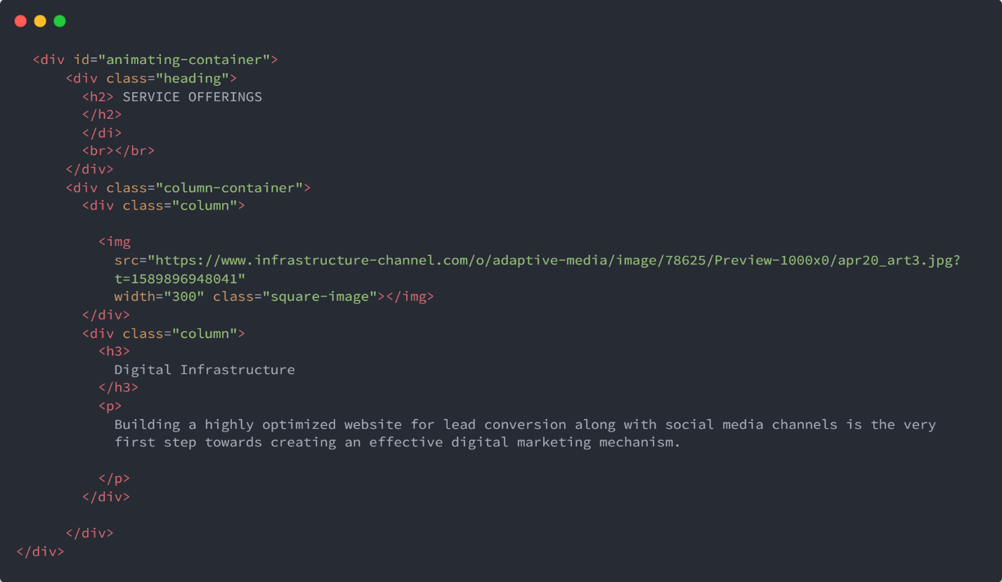

CSS for entire page

Here we have main container, column container

In the main container it basically unresponsive and column container is responsive. We have set it up column container to appear elements side by side on desktop. As in flex direction is row.

On mobile as you can see in the media I have set flex direction to column in order to get this responsive.

Animation script

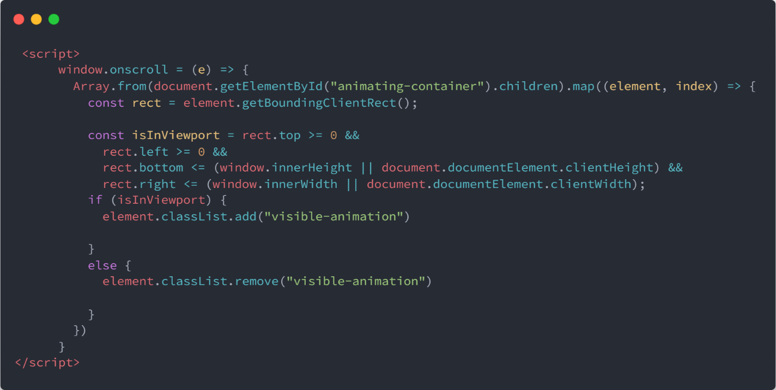

For the animation part we have added a visible animation in that I have used a transition.

Basically we added the css to the required element, when its visible in the display, the opacity level goes 0-100 when required. When we scroll the window this script will run.

This transition work both side.

Contact Us

We have added modal using modal body class in bootstrap to have a pop up after submitting this contact form.

Created the form using a html and have added empty divs as form fields and used JavaScript to push data into those fields once someone hits the submit button.

We have done validation using JavaScript

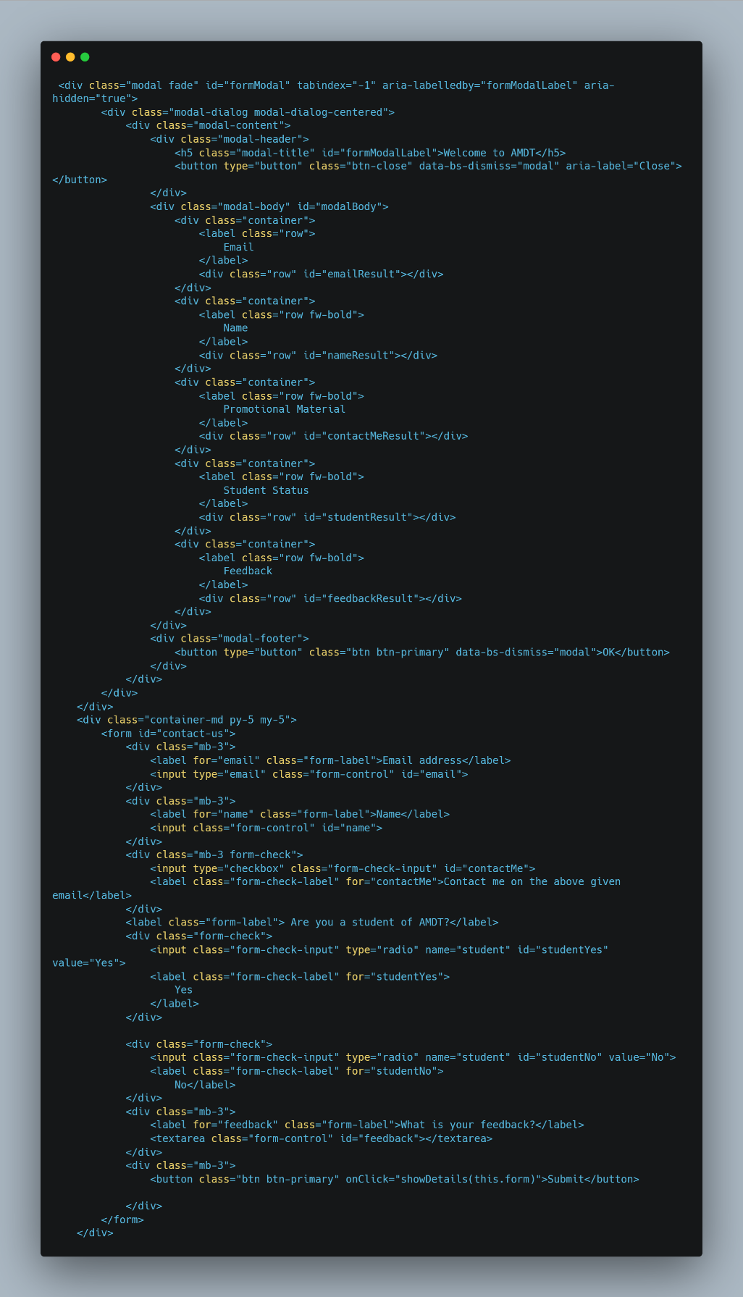

* 1. JAKOB NIELSEN’S USABILITY PRINCIPLES Application

First of all to design this website we have selected a very minimal design if you look at the landing page we have used a lot of white space to keep the aesthetic look.

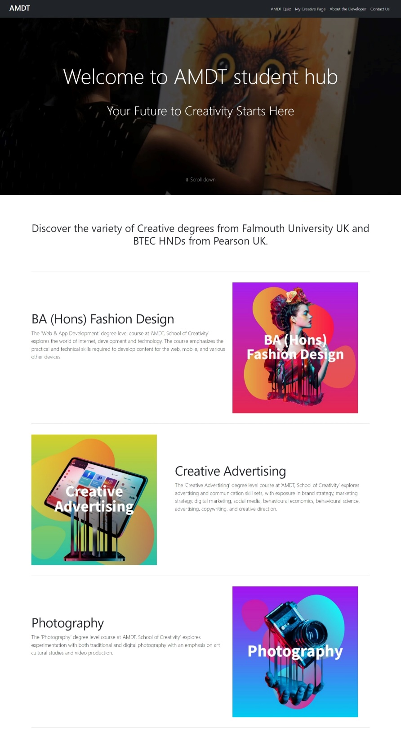

Secondly we have use the same accent colors to keep the brand consistency. As you can see in the screenshots

Apart from that we have used Error prevention as well.

Website Feedback

1. Better to add a proper footer
2. Use more visuals to make the website visually pleasing

Agreed. I will integrate those.